# Introduction:

CKF Group Malaysia, which is also referred as CKF is a global e-commerce enterprise that focuses on providing a wide range of famous products in many categories. These categories include of best-selling goods like cell phones, home appliances, accessories, and baby supplies. CKF has become a household name in the area by attracting loyal consumers and growing at an exponential rate. But the rapid expansion of CKF has also brought up some difficulties which is mainly related to product delivery and order fulfillment. The product delivery system (PDS) which CKF is currently using has not been able to support the company's growth trajectory. There are lot of difficulties that CKF is facing from which lack of user-friendliness, scalability constraints, and security difficulties are the common difficulties. These flaws make it more difficult for CKF to satisfy client demands and effectively handle the rising demand for its goods.

The task for our team is to use Remote Method Invocation (RMI) technology to develop a new Product Delivery System (PDS) for CKF. RMI will simplify distributed system development by enabling communication between client and server applications. Java programming will be used to build the system and will guarantee the username verification and secure communication during the registration process. The client application will provide options for both a graphical user interface and a command line which will provide flexibility. SSL or TLS technology will be used to protect communication between the client and server components in order to increase security.

# Problem Overview:

In the constantly evolving world of e-commerce, CKF Group Malaysia's Product Delivery System (PDS) is facing drawback which is forcing in compromising in its efficiency. The major issue has developed in its usability due to complex user interfaces in the system which is also impacting negatively in its internal operating efficiency and customer experience. Not only in usability, the PDS has also encounter difficulties with scalability which has made difficult to efficiently adjust to the growing market demand for CKF's varied product categories. Delivery delays, issues with inventory control, and an overall incapacity to keep up with the market's explosive expansion are some examples of the difficulties. Additionally, inefficiency in delivery processes has cause order fulfillment to be delayed and error-prone.

As a result, these difficulties has made customers dissatisfied which damages trust and can cause revenue loss for CKF. In order to overcome these difficulties, CKF has understood the necessity of developing a new PDS with a user-friendly interface, scalability, effective control over delivery operations, strong client account management, and extensive reporting abilities.

In order to resolve this present issues, CKF has plan to build up new PDS system with the help or by using RMI and Java programming language for long-term success in the competitive

e-commerce industry by gaining consumer happiness and streamlining internal operations.

# Requirements:

To address the drawbacks of the current PDS system and in order to meet the needs of CKF Group Malaysia, our team has developed the following project specifications:

Functional Requirements:

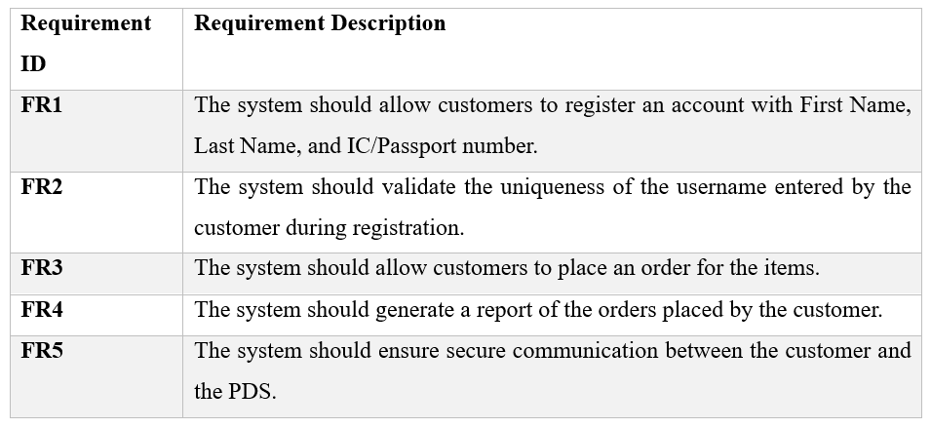

Non-Functional Requirements:

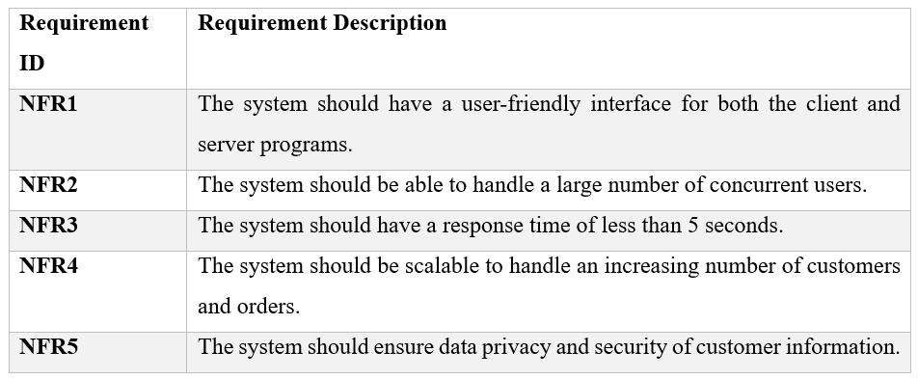

# Research and design:

The team started by figuring out what the new Product Delivery System needed using things like use-case, ER, and database diagrams. Our team did significant research to find out what features and stuff or requirement the system had to have. We also looked into different tools and technologies and ended up picking Java and RMI for the project.

## Use-case diagram:

This diagram displays that the features used are available to both customers and administrators. Customers can sign up, make orders, check their order status, and create reports right away. Administrators can regulate products, process or regulate orders, manage user accounts, and produce reports. The graphical diagram illustrates how users can interact with the system, highlighting essential functions and their connections.

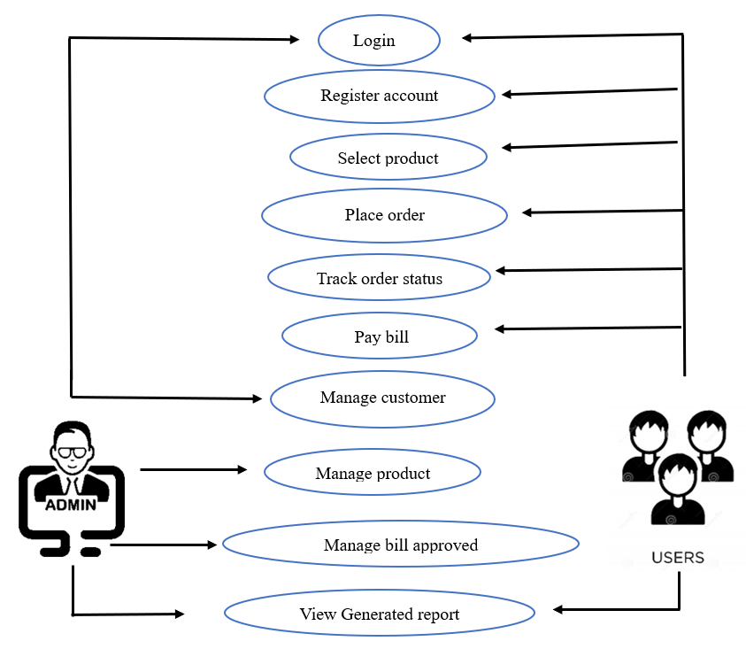

## Database Diagram:

The project's database diagram presents an organized data architecture which is designed in such a way that the architecture will facilitate the effective administration of CKF Group Malaysia's product delivery system. The architecture comprises of interconnected tables which are responsible for storing and structuring data associated with deliveries, customers, orders, items, and different product categories.

## ERD (Entity Relationship Diagram):

Our product delivery system which has the Entity-Relationship Diagram (ERD) illustrates crucial relationships among entities such as customers, orders, items, and details. These entities are interlinked which offering a transparent representation of the data organization within the system. The ERD plays a vital role in guiding the design and development of the system by presenting entities and their interconnections between them.

# Testing

Testing represent an essential component of every software development effort which including the PDS system for CKF. The testing process plays a pivotal role in verifying the system's proper functionality which should be aligned with customer requirements with the lack of defects. Presented below are various tests conducted for our project.

|  |  |  |
| --- | --- | --- |
| Genre of testing | Outline | Scenario of our System Test |
| Unit Testing | Individual system components evaluated independently. | Verifying the accuracy of data storage by checking the registration procedure for creating a new consumer account. |
|  | Investigating how various system components interact with one another. | Ensuring accurate data transmission by testing the communication between the client program and server program using RMI. |
|  | Conducting extensive evaluation of the entire system. | Verifying the proper functionality of the entire system by testing end-to-end processes which includes user registration, product ordering, and report generation. |
|  | Analyzing the system without prior knowledge of its internal workings or source code. | Analyzing the user interface of the user program to ensure it is user-friendly and straight forward. |
|  | Reviewing the system while taking into consideration its internal logic or source code. | Reviewing the secure and accurate handling of customer data by testing the logic of the server program. |
|  | Verifying that the system meets the needs and requirements of actual users. | Granting a group of user access to the system and collecting feedback on their user experience. |

# Techniques used in the development of RMI application:

# Relation: Distributed system and Blockchain

In the process of development of the CKF Product Delivery System (PDS), the relation between a distributed system and blockchain plays a crucial role in order to help to shape the architecture's core principles. To enhance fault tolerance and scalability, Remote Method Invocation (RMI) is utilized for communication between the client and server programs establishes a distributed system, distributing components across nodes. The core idea of blockchain which runs on a decentralized peer-to-peer network is to provide security and transparency which is reflected in this decentralization. Using cryptographic techniques, the distributed system and blockchain both provide secure communication which is very important factor in the PDS since it safeguards data while it is in transit and also guards from illegal access.

While a distributed system focuses on data consistency and integrity through consensus algorithms and the blockchain takes these principles more further by creating a fixed ledger which is resistant to tampering and helps to provide a transparent history of transactions.

Additionally, the concept of smart contracts which is inherit to blockchain platforms offers a medium for programmable and automated actions which will help to enhance the efficiency and security of certain aspects of the PDS.

# Conclusion:

The project focused on a development, and implementation of the new Product Delivery System (PDS) in order to mark a significant approach toward overcoming the challenges stated by the previous system. To enhance the scalability, fault tolerance, and user-friendly interfaces of the PSD, Remote Method Invocation (RMI) technology and a distributed system architecture made was utilized. To ensures the protection of sensitive data with the implementation of a robust registration process which adds an additional layer of security was due to the incorporation of secure communication through SSL/TLS technology. The utilization of Java programming language contributed in enhancing the system's flexibility, supporting both command line and graphical user interfaces for the client program. Overall, the project not only resolves the identified shortcomings in the existing PDS but also lays the foundation for future enhancements. All this helped in embracing the principles of decentralization, security, and adaptability in the evolving world of e-commerce.